Thelma Chalifoux and Soraya Hafez School IPD Projects

Mechanical / Energy Modelling

Location

Edmonton, Alberta, Canada

Client

Edmonton Public School

Terri Gosine

T: 780.429.8000;

E: [terri.gosine@epsb.ca](mailto:terri.gosine@epsb.ca)

Architect

ACI Architects

Eddo Cancian

T:780.702.8378

E: ecancian@aci-arch.com

contractor

ICON Industrial Contractors

Rob Nespliak –

T: 780.455.2299

E: rob@iconindustrial.net

Contract duration

November 2017 to February 2020  
(both schools)

Total project cost (CAD)

$28M (Thelma Chalifoux)

$19M (Soraya Hafez)

Contract value (CAD)

$313,700

Scope of work

Mechanical / Energy Modelling

Key personnel

Senior Management Team Member

Scott Koehn, P.Eng., LEED® AP

Mechanical / Energy Model (PIT)

Glen Tichkowsky, MSc., P.Eng., LEED® AP (BD+C)

Mechanical Design

Paul Pertich, P.Eng.

Project description

Figure : (Top-Bottom) Thelma Chalifoux School and Soraya Hafez School in Edmonton, AB

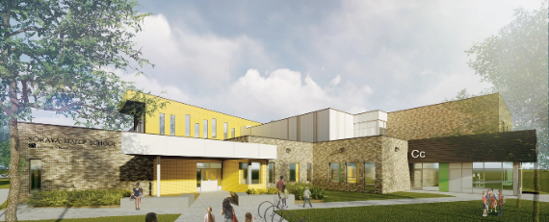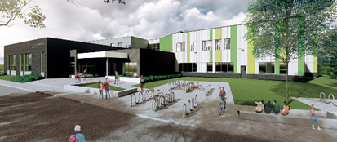

Englobe was retained to design two academic facilities that were dedicated to two women who championed diversity and inclusivity.

Thelma Chalifoux School has 88,500 SF and the capacity to accommodate about 900 grades 7 to 9 students. The school is dedicated to the memory of Thelma Chalifoux, a former senator and Métis activist who dedicated her life to teaching the history and culture of the Métis people. Chalifoux founded a consulting company for cross-cultural training, and in 1997, became the first Métis woman to be appointed to the Canadian Senate. It features an impressive performance art room, a modern teaching kitchen, and an outdoor project patio - all intended to develop skills and enhance the educational experience of its students.

The Soraya Hafez School has 58,900 SF and was designed to accommodate up to 650 K-6 students. The school is named after Soraya Hafez, an Edmonton-based teacher who is an advocate for Arabic culture and language. Hafez has been recognized and awarded for promoting the Arabic language and its culture. She has also served as the President of Edmonton’s Canadian Council of Muslim Women and was a long-standing member of the Arab Jewish Women’s Peace Coalition. Both schools were designed to provide bright, naturally lit learning spaces throughout the building, and were filled with gathering spaces, outdoor playgrounds, and fully furnished learning spaces to promote “learning communities”, where can students and teachers can collaborate.

Scope of work

“Big Room” approach: The projects allowed our team to collaborate with various stakeholders using the IPD method, where everybody involved worked together; and shared core values and project goals established from the outset, ensuring that everybody was on the same page throughout. The IPD team held Big Room meetings to establish and track project goals and values, and to more effectively resolve project issues. Using IPD, tasks were performed by the most efficient team members, regardless of their “traditional” roles.

Teamwork, creativity and collaborative skills and going “Above and Beyond” what was required: Englobe Engineering is always excited to get involved in school and education projects, especially those that cover underserved areas like the Soraya Hafez School. Our team realizes the importance of giving future generations a comfortable, energizing place to learn and thrive. This project was an opportunity to collaborate with Delnor Construction (General Contractor) for this project.

Sustainable development

Sustainable Procurement Practiced that Aligned with the City’s Sustainable Procurement Policy – C556B:

The Thelma Chalifoux School was designed using Building Information Modelling (BIM) to better focus on cost optimization opportunities while still ensuring that all project goals are being met and values are being upheld. Our mechanical engineering team worked closely with the mechanical contractor to ensure the highest quality systems design for the school. Our energy modelling team also worked closely with the IPD group to meet the energy code compliance and LEED® certification and optimize costs. In order to complete the Soraya Hafez project on time and achieve project goals, the IPD team ensured that the most efficient team member performed the required tasks, even when it varied from their traditional roles.